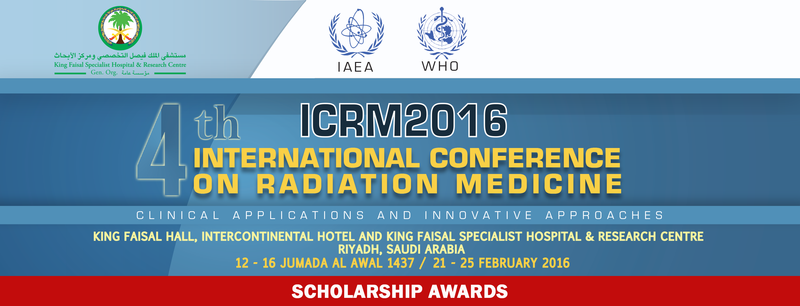

ICRM2016 is the 4th International Conference on Radiation Medicine (ICRM) organized by King Faisal Specialist Hospital & Research Centre (KFSH&RC) in collaboration with leading national and international organizations and professional societies. The Conference aims to provide venues that enhance the development of healthcare professionals' knowledge and skills on the state of the art practice of radiation medicine. The event provides opportunities to share discuss and disseminate innovative approaches, techniques, applications and best clinical practices. It also provides presentations on the state-of-art technology pertaining to the use of radiation in medicine including, but not limited to, diagnostic & interventional imaging, radiation oncology, radiation physics, neuroradiology: head & neck, nuclear medicine, radiobiology and radiation protection. In congruence with its aim, the ICRM2016 provides a limited number of travel awards to prospective registrants on a competitive basis. Interested parties are encouraged to apply using this application form.

Scholarship Guidelines:

Prospective registrants who satisfy the requirements are encouraged to apply.

- Application must be submitted directly to the ICRM2016 per registration instructions.
- Preference will be given to applicants who are not past ICRM Scholarship Award recipients.
- Preference will be given to applicants who have abstracts accepted for presentation at the ICRM2016.

The total number of Scholarship Awards will be determined by the ICRM2016 Organizing Committee.

For further information, prospective applicants are encouraged to visit the ICRM2016 website at www.radmed.org. The application deadline is 15 January 2016.

Submit completed application with a copy of your CV or resume to:

Ms. Josephine Veridiano
Biomedical Physics Department
King Faisal Specialist Hospital and Research Centre
Riyadh, Saudi Arabia
Fax #: 00966-11-4424777
Email: josfin@kfshrc.edu.sa
Tel #: 00966-11-4427879
ICRM2016 SCHOLARSHIP AWARD APPLICATION FORM
Applicant's Name (Indicate Last Name in Capital Letters):
Gender: | Male Female |  |  | Highest Education attained (degree):
Occupation:
Work Address:
City: |  |  |  |  | Country:
Telephone: |  |  |  |  | E-mail:
Have you submitted an abstract? |  |  |  |  |  | Yes No
Have you received an ICRM Scholarship Award in the past? |  |  |  |  |  | Yes No
Briefly state your personal goals that you aim to achieve by attending the ICRM2016:

___________________________________________ _______________________________________________________
Applicant Signature Date
-----------------------------------------------------------------------------------------------------------------------------
For ICRM2016 Official Use Only:

Approval Outcome: Yes __________ No ___________

Approved Award: Free Registration Fee ______ Hotel accommodation ______ Airline Ticket ______

Reviewer: ______________________________________________ Date: _________________________________________
ICRM2016 Organizing Committee

